1. Open Pycharm.
2. Go to File -> Settings. Left click.

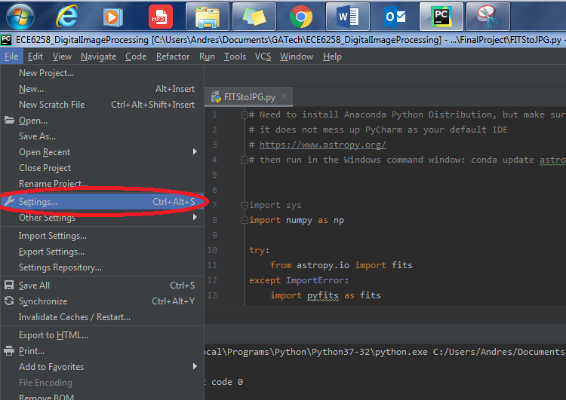

1. Left click Project Interpreter

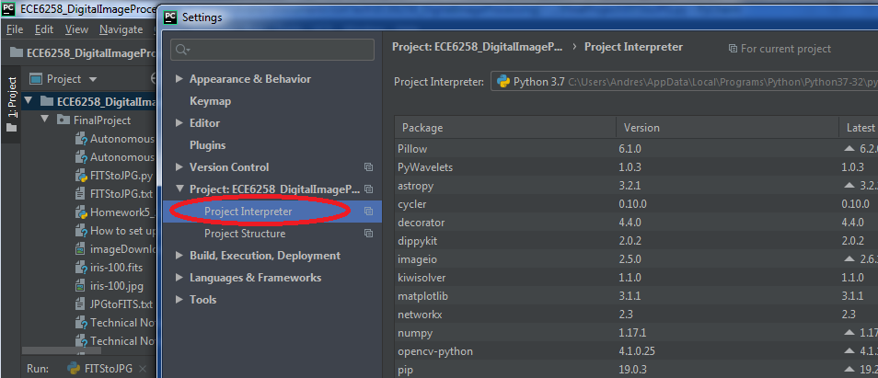

1. Left click on Add (plus sign)

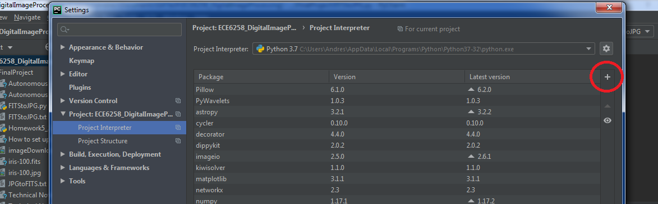

1. Search “astropy”. Once you find it, check “Install to user’s…” and then click on “Install Package”.

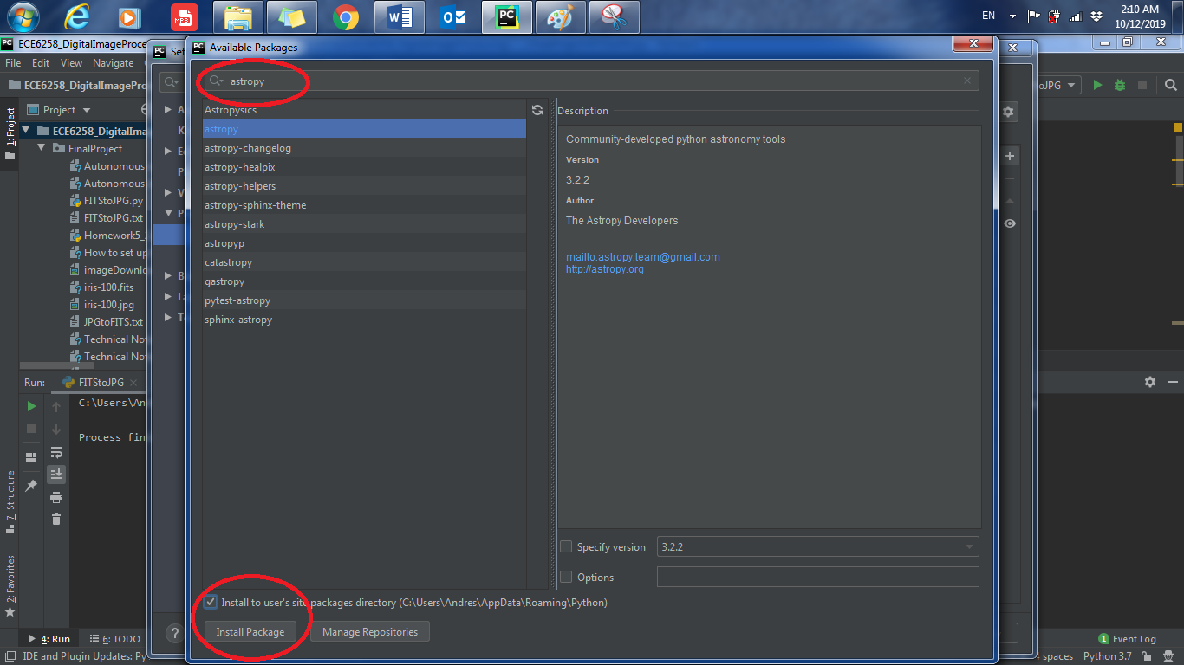

1. Done.